[Team Member(s) Name(s)]

This document references sections and descriptions found in ISO/IEC/IEEE 29148:2018(E)**): Systems and software engineering — Life cycle processes — Requirements engineering; Annex A (Operational concept document, OpsCon)** found at IEEE Xplore (http://ieeexplore.ieee.org/Xplore) through the University of Texas at El Paso Library. – Dr. Oscar Mondragon.

Table of Contents

1 Scope 3

1.1 Identification 3

1.2 Document Overview 3

1.3 System Overview 3

2 Reference Document 4

2.1 Relevant Acronyms 4

3 The Current System 4

3.1 Background, Objectives, and Scope 5

3.2 Operational Policies and Constraints 5

3.3 Description of the Current System 5

3.4 Modes of Operation for the Current System 6

3.5 Description of the Current System Environment 6

3.6 User Classes 7

3.6.1 Organizational structure 7

3.6.2 Profiles of user classes 7

3.6.3 Interactions among user classes 7

3.6.4 Other involved personnel 7

3.7 Support Environment 7

3.8 Issues and Problems with the Current System 7

4 Justification for and Nature of the Proposed Changes 8

4.1 Justification for the Desired Changes 8

4.2 Description of the Desired Changes 8

4.3 Priorities among Changes 9

4.4 Changes Considered but Not Included 9

4.5 Assumptions and Constraints 9

5 The Proposed System 10

5.1 Background, Objectives, and Scope 10

5.2 Operational Policies and Constraints 10

5.3 Description of the Proposed System 11

5.4 Modes of Operation 12

5.5 Description of the Intended Environment for the Proposed System 12

5.6 User Classes and Other Involved Personnel 12

5.6.1 Organizational structure 12

5.6.2 Profiles of user classes 12

5.6.3 Interactions among user classes 12

5.6.4 Other involved personnel 13

5.7 Description of Intended Use of the Proposed System 13

5.8 Support Environment 13

6 Operational Scenario Description 13

6.1 List of Actors 13

6.2 List of Services 13

6.3 Use Case Diagrams 14

6.4 Operational Scenarios 14

7 Summary of Impacts 15

7.1 Operational Impacts 15

7.2 Organizational Impacts 15

7.3 Impacts During Development 15

8 Analysis of the Proposed System 16

8.1 Summary of Improvements 16

8.2 Disadvantages and Limitations 16

8.3 Alternatives and Trade-Offs Considered 16

9 Notes 16

10 Appendices 17

**Document Control** 18

**[1]** **Approval** 18

**[2]** **Document Change Control** 18

**[3]** **Distribution List** 18

**Revision History** 18

# Scope

The Computer Science (CS) department recognizes the complexity, time, and effort that is needed in order to perform accordingly in the MSSwE program director position. The departments wants a system that will facilitate the work done by the program director, specifically in the work related to advising current and upcoming students. In addition, the system should address and facilitate most of the responsibilities associated to the role that are listed in the problem description. The University of Texas at El Paso (UTEP) and the program director for the MSSwE program are collaborating to develop the MSSwE AMS system that will provide the ability for both the program director and the program student to communicate more effectively through the reduction of manual input from the program director. This system will deliver relevant information in a user-friendly manner to both the program director and the student.

## Identification

< MSSwE Advising Management System >

< MSSwE AMS >

<1.0>

## Document Overview

This document describes the concepts of operations for a system that will aid advisors during the process of enrollment of a student. The purpose of this document is to communicate the user’s needs for and expectations of the proposed system to the acquire and/ or supplied. In addition, this document serves the purpose of communicating the supplier’s understanding of the user’s need and how the system shall operate to fulfill those needs.

This document defines the Operation Concept for the MSSeW AMS system. The ConOps will identify some key requirements and assumptions in detail.

The intended audience of the ConOps is Dr. Adrian Mondragon (Program Director), Cristian Molina, Bryan Molina, Diego Rivera, WIlliam Palafox, and Jonathan Argumedo. The individuals mentioned will be able to reference this this document in order to determine their needs and desires have been correctly specified. The intended audience mentioned above is the audience that’s authorized to read and review this document. External audience should not have access to this document, it is expected by the intended audience and the authors to maintain the privacy of this document.

## System Overview

The purpose of this system is to facilitate the communication of the program director and the students. The system will facilitate the communications by automating the monotonous process the program director must complete. The system’s automation will keep the repetition of some advising steps. Some of the responsibilities that are intended to be reduced but are not limited to the following: Reduce manual input, increase the attendance to appointments, and automating crucial process of the advising process [3]. The system will be running in conjunction with the SSO Login system provided by the University of Texas at El Paso, CS Scheduling system, and the CS Department.

# Reference Documents and Acronyms/abbreviations

|  |  |  |  |
| --- | --- | --- | --- |
| # | Document Title | Version | Date |
| 1 | Interview Questionnaire | 1 | 02/17/2021 |
| 2 | Interview Questionnaire Feedback | 1 | 02/17/2021 |
| 3 | Class Project MSSwE Advising Spring 2021 | 1 | 2/10/2021 |
|  |  |  |  |
|  |  |  |  |

## Relevant Acronyms

|  |  |
| --- | --- |
| Acronym /  Abbreviations | dEFINITION |
| UTEP | The University of Texas at El Paso |
| MSSWE | Master of Science in Software Engineering |
| IT | Information Technology |
| CS | Computer Science |
| SSO | Single Sign On |
| cstech | Computer Science Technology Support |
| SOI | System of Interest |
|  |  |
|  |  |
|  |  |
|  |  |
|  |  |
|  |  |
|  |  |
|  |  |
|  |  |
|  |  |
|  |  |

# The Current System

The MsSWE advisor of the University of Texas at El Paso does a big load of administrative work that is manual, repetitive and error prompt when advising students. Every time he advises someone, he does a combination of the following actions, all of which are a manual process:

* Advising students
* check available courses
* check available courses with seats open
* add their course grades to the student's records
* Add student's courses outside prescribed electives
* Adding course grades
* Adding courses outside prescribed electives
* Sending substitutions to graduate school for non-prescribed courses
* Checking that a program plan meets graduation requirements
* Uploading program plans and its advising forms ([*Class Project MSSwE Advising Spring 2021.pdf*](https://blackboardlearn.utep.edu/bbcswebdav/pid-3742797-dt-content-rid-118291619_1/xid-118291619_1)*)*

This process is tedious and can be automated, hence the motivation for the development of an automation system.

## Background, Objectives, and Scope

<**Objective and Motivation:** to save time to the MsSWE advisor by automating the advising process. ([*Class Project MSSwE Advising Spring 2021.pdf*](https://blackboardlearn.utep.edu/bbcswebdav/pid-3742797-dt-content-rid-118291619_1/xid-118291619_1)*)*

**Background:** UTEP's MsSWE advisor talks to university students interested in pursuing a master's degree in software engineering. This process involves numerous manual processes that can be automated. ([*Class Project MSSwE Advising Spring 2021.pdf*](https://blackboardlearn.utep.edu/bbcswebdav/pid-3742797-dt-content-rid-118291619_1/xid-118291619_1)*)*  
  
**Scope:** The boundaries of the system are limited to the Computer Science department at UTEP. ([*Class Project MSSwE Advising Spring 2021.pdf*](https://blackboardlearn.utep.edu/bbcswebdav/pid-3742797-dt-content-rid-118291619_1/xid-118291619_1)*)*

**Goals & Strategies:** To advice, guide and record the current progress of students in their software degree plans. The strategies involve sending students pre-advising forms, sending emails to the graduate school office and keeping several electronic records (e.g. excel and word) of advised students on OneDrive ([*Class Project MSSwE Advising Spring 2021.pdf*](https://blackboardlearn.utep.edu/bbcswebdav/pid-3742797-dt-content-rid-118291619_1/xid-118291619_1)*)*  
  
**Modes of operation: None**. (Source: Customer Interview II)

1. **Classes of users:** Staff (all functionality), Assistant (pending level of authority), student. (Client Interview I)  
     
   **Interfaces:** Goldmine, CS Scheduling, CS Front Desk, CSTech, Graduate School Office, UTEP Single Sign On, UTEP Email Server, Office 365: One Drive, Outlook, and Excel ([*Class Project MSSwE Advising Spring 2021.pdf*](https://blackboardlearn.utep.edu/bbcswebdav/pid-3742797-dt-content-rid-118291619_1/xid-118291619_1)*, Interview I, Interview II)*

## Operational Policies and Constraints

* The number of personnel available to use the system must include all students interested in the MsSWE master's program, the MsSWE advisor, the Computer Science Chair, the MsSWE assistant and technicians from CSTech (Client Interview I, Project Overview)

## Description of the Current System

1. The operational environment and its characteristics.
   1. The system's environment takes place at the University of Texas at El Paso, on the Computer Science department. The system is used by students and staff of the university. One characteristic of this environment is that the CS IT department regulates all programs running on it, so there are constraints coming from them.
2. **Major system components and the interconnection among those components;**
3. Interfaces to external systems or procedures.
   1. System interfaces with Goldmine, CS Scheduling and Graduate School, CSTech (Interview Questionnaire comments)
4. Capabilities, functions, and features of the current system.
   1. Promote the program
   2. Show program content and benefits to potential students
   3. Assess program applications and determine its acceptance to the program
   4. Attend career fairs
   5. Outreach with schools and industry
   6. Advise 2nd degree students
   7. Compare and contrast 2nd degree plans with MSSwE plans
   8. Advise prospective students from non-CS UG programs
   9. Advise prospective students from CS programs
   10. Advise prospective UG students from UTEP
   11. Advise Fast Track students interested in the program
   12. Advise MSSwE students
   13. Advise MSSwE with concentration in Secure Cyber Systems students
   14. Manage graduate internship for MSSwE and its concentration
   15. Review and approve degree plans for graduating students
   16. Update MSSwE information in catalog as needed
   17. Advise MSSwE students in their Plan and Goals
   18. Manage MSSwE Program Plan for students
   19. Upload to OneDrive MSSwE Advising Form and Program Plan after advising a student
   20. Send CS department Advising Form after advising a student
   21. Follow problems when students cannot register
   22. Identify substitutions and send request to Graduate School
   23. Request adding concentration to graduate school
   24. Check for course dependencies during advising
   25. Manage calendar for advising
   26. Negotiate out of advising schedule requests
   27. Send advising forms and pre-advising checklist to students
5. Charts and accompanying descriptions depicting inputs, outputs, data flows, control flows, and manual and automated processes sufficient to understand the current system or situation from the user’s point of view.  
   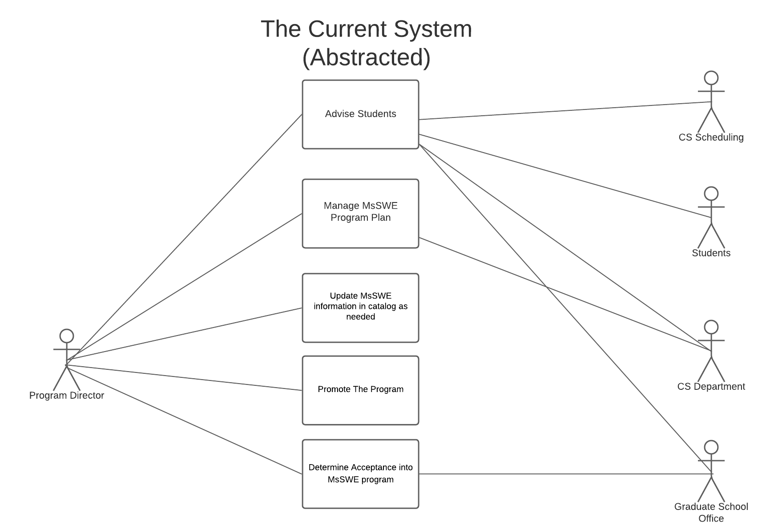  
   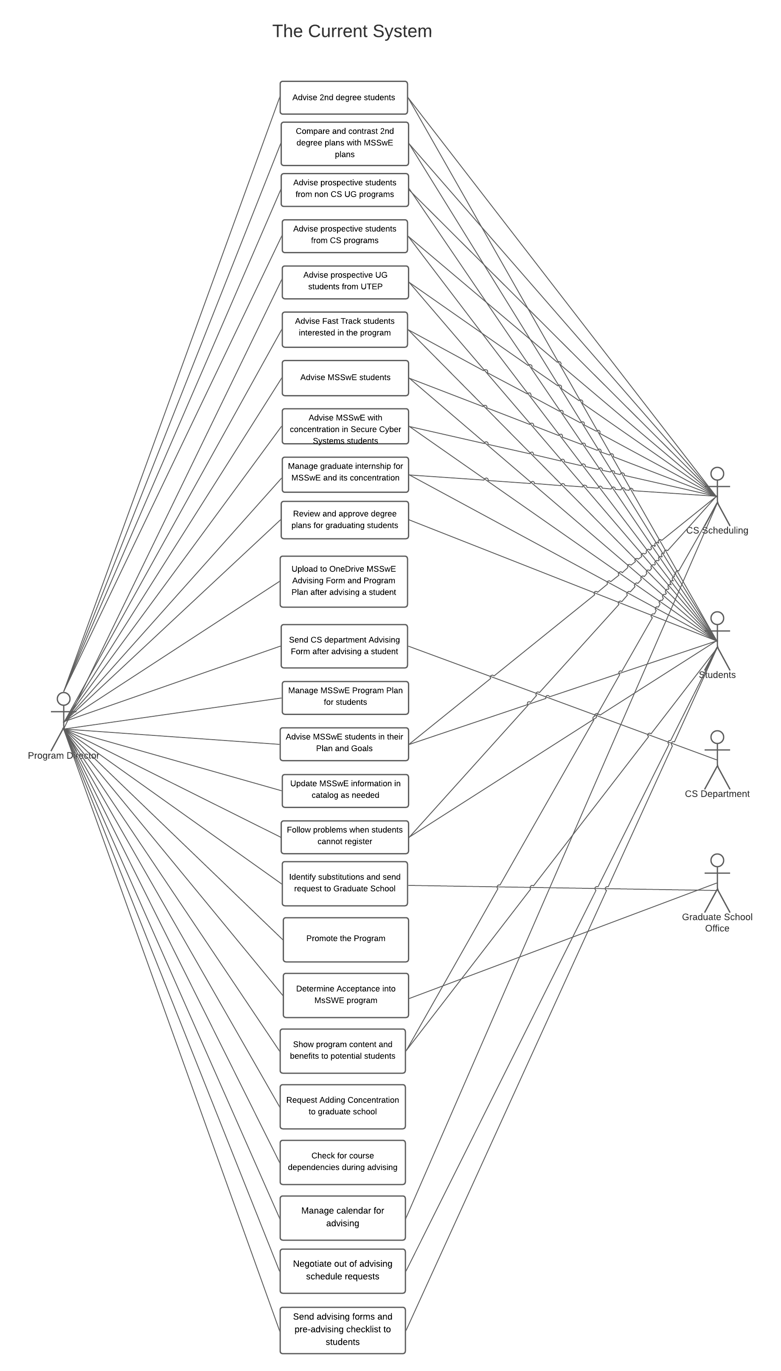
6. Cost of system operations;
   1. Client says there is no financial cost, presuming the university provides the software licenses for free, to utilizing the current system. (Customer Interview II).
7. Operational risk factors;
   1. Unclear, must ask client
8. Performance characteristics, such as speed, throughput, volume, frequency;
   1. Performance characteristic used to evaluate the system will be speed ([*Class Project MSSwE Advising Spring 2021.pdf*](https://blackboardlearn.utep.edu/bbcswebdav/pid-3742797-dt-content-rid-118291619_1/xid-118291619_1)*)*
9. **Quality attributes, such as: availability, correctness, efficiency, expandability, flexibility, interoperability, maintainability, portability, reliability, reusability, supportability, survivability, and usability; and Provisions for safety, security, privacy, integrity, and continuity of operations in emergencies.**
   1. Availability: The system seems to need to be available 24/7, but it's unclear yet.
   2. Correctness: The system seems to deliver a high degree of correctness
   3. Maintainability: The system is maintainable but it takes a lot of manual work to keep it updated
   4. Security: The system seems to be secure. Unsure, will ask client.

## Modes of Operation for the Current System

Not specified yet. Must ask the client.

## Description of the Current System Environment

The current system is regulated by CSTech. Even though CSTech usually does not directly interact with the system, they prohibit certain unsafe actions. (Interview I)

## User Classes

The current system consists of many manual tasks with no user classes. However, we will ask the client.

### Organizational structure

The current system is not integrated, but rather, a set of entities that the users must manually navigate and update accordingly. (Customer Interview II).

### Profiles of user classes

There seem to be no user classes in the current system. The current system is not integrated, but rather, a set of entities that the users must manually navigate between and update accordingly. (Customer Interview II).

### Interactions among user classes

There seem to be no user classes in the current system. The current system is not integrated, but rather, a set of entities that the users must manually navigate between and update accordingly. (Customer Interview II).

### Other involved personnel

CSTech: Even though they may not use the system, since they are not students nor advisors, they may regulate it or modify its code for security concerns.

## Support Environment

OneDrive operates as a support software to store the advising records of all students. ([*Class Project MSSwE Advising Spring 2021.pdf*](https://blackboardlearn.utep.edu/bbcswebdav/pid-3742797-dt-content-rid-118291619_1/xid-118291619_1)*)*

## Issues and Problems with the Current System

• Some students do not prepare for the advising session

• Some students do not attend appointments

• Some students do not fill out advising forms and pre-advising checklist

• Students do not have access to their Program plan

• Program plans may not be current with new catalog changes (course numbers change)

• Checking available courses each semester is a manual process

• Checking available courses with open seats each semester is a manual process

• Checking courses prerequisites each semester is a manual process

• Adding course grades is a manual process

• Adding courses outside prescribe electives is a manual process

• Sending substitutions to graduate school for non-prescribe courses is a manual process

• Checking that a Program Plan meets graduation requirements is a manual process (degree evaluation)

• Uploading a Program Plan and its advising form is a manual process

• Sending to student advising form and pre-advising checklist is a manual process

# Justification for and Nature of the Proposed Changes

In this sections, justification and proposed changes to the MSSwE AMS system are specifically stated. The current system requires changes due to the lack of automatization in the system. The current system has faults that complicate the communication between both the program director and the student. In some cases, even if communication is met, the monotonous process increases the gap for error. Therefore, the system requires changes that will facilitate the work done by the program director and automate many of the process.

## Justification for the Desired Changes

Justification for this new system is as follows:

1) The efficiency is something the current system lacks. Efficiency is one of the main functionalities the new system will achieve. In the current system, there are many monotonous processes that open the gap to errors for both the students and the program director. The errors present in the current system are produced by human errors; this could be traced to the significant number of steps the human must go through.

2) The current system is not well suited for remote work. The system is currently dependent on students and program advisors to keep track of a physical sheet that is needed throughout the advising process. During the pandemic, this current system suffered the exposure of many flaws.

3) The program is increasing its size, the demand for advising for students is growing and this only means that the errors will continue to increase as well. The manual labor is set to fail in the future with the expansion of the program.

## Description of the Desired Changes

1. *Capability changes*. This new system should prevent the students and program director from having to manually fill out most information on the forms by pulling the information directly from Goldmine. (Source: Customer Interview II)
2. *System processing changes*. Instead of manually filling out forms and reviewing the degree plan. The students and program director would get a one-stop-shop for reviewing the degree plan and choose classes the student wants to take next semester. (Source: Customer Interview II)
3. *Interface changes*. Forms will move from excel to a web form that will be prefilled with information from Goldmine. (Source: Customer Interview II)
4. *Personnel changes*. None. (Source: Customer Interview I)
5. *Environment changes*. This system will eliminate the need for the users to send notifications on the current status of the advising process as these will be handled by the system. (Source: Customer Interview II)
6. *Operational changes*. Once forms are successfully uploaded to a One Drive repository, CS Staff can get direct access to them instead of requiring the Program Director to submit them. The same will occur with the forms for the course substitutions. (Source: Customer Interview II)
7. *Support changes*. CS IT Team will need to get access to the system code and a test environment, so they can provide support for the system regarding problems, updates or patches.
8. *Other changes*. None at the moment.

## Priorities among Changes

Priorities have not been discussed at this moment, and we need to ask the customer to specify what subsystems have the most priority.

## Changes Considered but Not Included

At some point our system was expected to also manage student holds, but we must confirm with the customer if this is desired or required functionality.

## Assumptions and Constraints

At the moment we have the following assumptions:

1. User authentication can be done via the OAuth 2.0 protocol on the UTEP Single Sign On system.
2. Users can be assigned roles via an Azure AD group.
3. We can interface with Goldmine via an API, direct database access or flat file communication.
4. We can interface with the UTEP Outlook email server via an API.
5. We can interface with the UTEP One Drive server via an API.
6. We can create a service account to manage the system services and interaction with other UTEP systems such as Goldmine, One Drive and Outlook.

# The Proposed System

## Background, Objectives, and Scope

-This project will attempt to streamline the communications of the Program director to students with as much automation as possible to make their advising experience more integrated. Some motivations include automating the checking of available course by semester, checking available open seats, checking available courses with open seats. The scope of the project will not include processes involving financial aid. The actors for this project are: Program Director, Graduate School Office, CS Department, Students, UTEP Goldmine, UTEP Single Sign On, UTEP One Drive and UTEP Outlook.

## Operational Policies and Constraints

Policies:

* Once a Student schedules an advising appointment it cannot be canceled by the Program Director, only rescheduled.
* The Program Director can limit the access that the assistant has in the system.

Constraints:

* All users must be validated.
* There is only one user for the Program Director class in the system.
* There is only one user for the CS Chair class in the system.
* Courses cannot have overlapping schedules.

## Description of the Proposed System

1. The operational environment and its characteristics.
   1. The system's environment takes place at the University of Texas at El Paso, at the Computer Science department, specifically for the MSSwE program.
2. Major system components and the interconnection among those components.
3. Interfaces to external systems or procedures.
   1. The system interfaces with Goldmine, CS Scheduling, and Graduate School.
4. Capabilities, functions, and features of the proposed system (no change);
   1. Promote the program.
   2. Show program content and benefits to potential students.
   3. Assess program applications and determine its acceptance to the program.
   4. Attend career fairs.
   5. Outreach with schools and industry
   6. Advise 2nd degree students.
   7. Compare and contrast 2nd degree plans with MSSwE plans.
   8. Advise prospective students from non-CS UG programs.
   9. Advise prospective students from CS programs.
   10. Advise prospective UG students from UTEP.
   11. Advise Fast Track students interested in the program.
   12. Advise MSSwE students.
   13. Advise MSSwE with concentration in Secure Cyber Systems students.
   14. Manage graduate internship for MSSwE and its concentration.
   15. Review and approve degree plans for graduating students.
   16. Update MSSwE information in catalog as needed.
   17. Advise MSSwE students in their Plan and Goals.
   18. Manage MSSwE Program Plan for students.
   19. Upload to OneDrive MSSwE Advising Form and Program Plan after advising a student.
   20. Send CS department Advising Form after advising a student.
   21. Follow problems when students cannot register.
   22. Identify substitutions and send request to Graduate School.
   23. Request adding concentration to graduate school.
   24. Check for course dependencies during advising.
   25. Manage calendar for advising.
   26. Negotiate out of advising schedule requests.
   27. Send advising forms and pre-advising checklist to students.
5. Charts and accompanying descriptions depicting inputs, outputs, data flows, control flows, and manual and automated processes sufficient to understand the proposed system or situation from the user’s point of view;

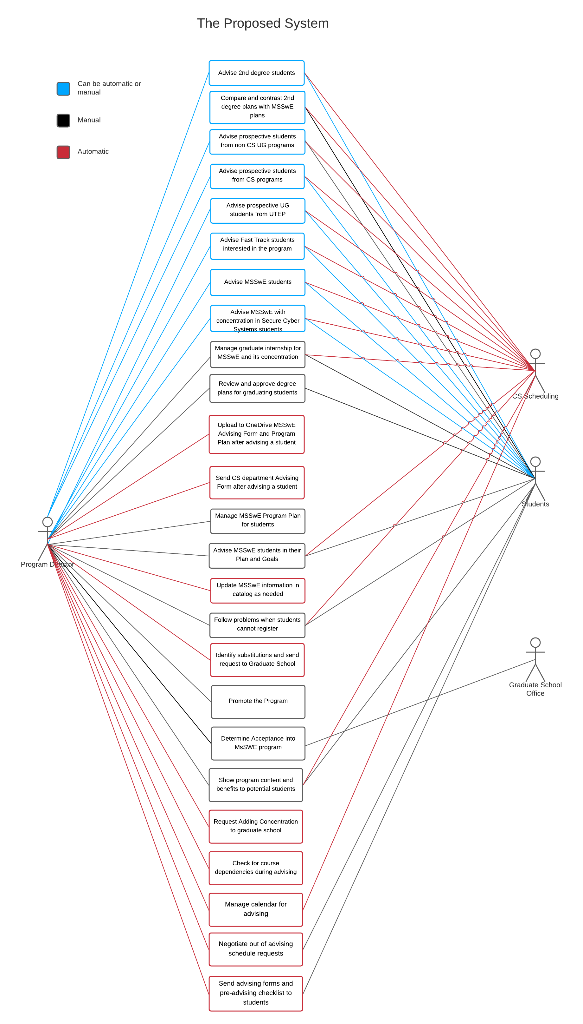

1. Cost of system operations;
   1. There should be no additional cost for the customer to operate the system beyond current staffing levels. If any, the system should reduce the cost in man-hours of operating the program. (Source: Interview II)
2. Operational risk factors;
   1. Developers must ensure the system is secure and complies with the safety regulations that will be outlined by the UTEP CS IT department at a later interview. (Source: Customer Interview II)
3. Performance characteristics, such as speed, throughput, volume, frequency;
   1. Performance characteristic used to evaluate the system will be speed ([*Class Project MSSwE Advising Spring 2021.pdf*](https://blackboardlearn.utep.edu/bbcswebdav/pid-3742797-dt-content-rid-118291619_1/xid-118291619_1)*)*
4. Quality attributes, such as: availability, correctness, efficiency, expandability, flexibility, interoperability, maintainability, portability, reliability, reusability, supportability, survivability, and usability;
   1. Availability: The system will be available 24/7 unless under maintenance.
   2. Security: The system will utilize UTEP SSO to authenticate users.
   3. Correctness: The system is less prone to human error since many processes have been automated.
   4. Efficiency: The system is greatly efficient due to the automatization of clerical work.
5. **Provisions for safety, security, privacy, integrity, and continuity of operations in emergencies.**

## Modes of Operation

The client has not requested any specific modes of operation. (Confirmed on Customer Interview II)

## Description of the Intended Environment for the Proposed System

The current system is regulated by CSTech. Even though CSTech usually does not directly interact with the system, they prohibit certain unsafe actions. (Interview I)

## User Classes and Other Involved Personnel

Program Director: Can access everything in the system except for scheduling an advising session.

Assistant: Can perform the tasks that the program director allows him to do.

CS Department: Handles the advising forms.

Goldmine: Provides most of the data required for the advising session.

UTEP Single Sign On: Authorizes users to use the system.

UTEP Email Server: Sends Emails with information compiled from the advising session to the CS Department.

Office 365 OneDrive: Stores advising form and program plan from students.

CSTech: Performs maintenance on the system. Has no access otherwise.

Students: Able to schedule an advising appointment.

### **Organizational structure**

The structure of the system is still unclear.

### **Profiles of user classes**

* 1. **Advisor:** The MsSWE advisor, he shall be able to do the following actions through the system:
  2. Advise 2nd degree students.
  3. Compare and contrast 2nd degree plans with MSSwE plans.
  4. Advise prospective students from non-CS UG programs.
  5. Advise prospective students from CS programs.
  6. Advise prospective UG students from UTEP.
  7. Advise Fast Track students interested in the program.
  8. Advise MSSwE students.
  9. Advise MSSwE with concentration in Secure Cyber Systems students.
  10. Manage graduate internship for MSSwE and its concentration.
  11. Review and approve degree plans for graduating students.
  12. Update MSSwE information in catalog as needed.
  13. Advise MSSwE students in their Plan and Goals.
  14. Manage MSSwE Program Plan for students.
  15. Upload to OneDrive MSSwE Advising Form and Program Plan after advising a student.
  16. Send CS department Advising Form after advising a student.
  17. Follow problems when students cannot register.
  18. Identify substitutions and send request to Graduate School.
  19. Request adding concentration to graduate school.
  20. Check for course dependencies during advising.
  21. Manage calendar for advising.
  22. Negotiate out of advising schedule requests.
  23. Send advising forms and pre-advising checklist to students.

Staff: Staff users include the MsSWE advisor and the Computer Science chair, the Graduate School Office and CSTech. Staff users have access to see and edit the system information but cannot advise students

Students: UTEP CS Students or people interested in the MsSWE program

Assistant: Person in charge of helping the MsSWE advisor. His level of authority is still under review, but we know it exists. It shall have as much as authority as the MsSWE advisor delegates.

### **Interactions among user classes**

Advisor: Interacts with the following user classes

* + Students: The advisor advises students through the system
  + Staff: Advisor reports information about student advising to the staff
  + Assistant: Advisor gives authority for assistant to complete some of his responsibilities

Students interact with the following user classes:

* Advisor: Students will manage their advising appointments through the system, and they are advised by the advisor

Staff interact with the following user classes:

* + Advisor: Staff can check all documentation that the advisor saves from advised students

### **Other involved personnel**

Outside of CSTech, which is part of the staff, no one.

## **Description of Intended Use of the Proposed System**

**To automate the pain areas of advising, which are the following:**

• Some students do not prepare for the advising session

• Some students do not attend appointments

• Some students do not fill out advising forms and pre-advising checklist

• Students do not have access to their Program plan

• Program plans may not be current with new catalog changes (course numbers change)

• Checking available courses each semester is a manual process

• Checking available courses with open seats each semester is a manual process

• Checking courses prerequisites each semester is a manual process

• Adding course grades is a manual process

• Adding courses outside prescribe electives is a manual process

• Sending substitutions to graduate school for non-prescribe courses is a manual process

• Checking that a Program Plan meets graduation requirements is a manual process (degree evaluation)

• Uploading a Program Plan and its advising form is a manual process

• Sending to student advising form and pre-advising checklist is a manual process

## **Support Environment**

OneDrive operates as a support software to store the advising records of all students. ([*Class Project MSSwE Advising Spring 2021.pdf*](https://blackboardlearn.utep.edu/bbcswebdav/pid-3742797-dt-content-rid-118291619_1/xid-118291619_1)*)*

# Operational Scenario Description

## List of Actors

1. Program Director: In charge of advising students, and prospective students. Can approve advising forms for the students to be able to take classes.
2. Students: Students enrolled or interested in joining the Master of Science in Software Engineering program. They need to submit advising forms to the program director and schedule and advising appointment for them to be able to enroll in the classes they request.
3. Computer Science Department Staff: Should be able to see the advising forms approved by the program director in order to remove student holds.
4. Goldmine: System of record for student’s academic information as well as the class catalog and degree program information.
5. UTEP Single Sign On: Cloud application suite in charge of handling user authentication,
6. UTEP Email Server: Server used to manage email notifications and calendars.
7. Office 365 One Drive: the one drive file repository.
8. UTEP Graduate School Office: This office will receive course substitution forms.

## List of Services

1. Authenticate User: Any user of the system will be required to log in, so they can get access only to the services they are allowed to use and to restrict the information they have access to.
2. Request Advising Appointment: Student or Program Director can request to schedule an advising appointment.
3. Change Advising Appointment: Student or Program Director can request to re-schedule an advising appointment.
4. Cancel Advising Appointment: Student or Program Director can request to cancel an advising appointment.
5. Check Student Degree Plan: Student or Program Director can request to see the advised student degree plan. The degree plan will list courses taken as well as the student grades on each of the courses taken so far.
6. Check Available Courses: Student or Program Director can request to see the courses offered next semester (if available) that the advised student can take. This list should include all courses offered by the Computer Science Department that are not full yet or conflict with other courses the student has already enrolled in.
7. Submit Advising Forms: Student is required to send all the required advising forms filled out before scheduling and advising appointment.
8. Approve Advising Forms: Program Director can approve the advising forms submitted by the student, so they can be later uploaded to one drive.
9. View Approved Advising Forms: Computer Science Department staff and program director will be able to look and search all the approved advising forms in the system.
10. Submit Course Substitution Request: Program Director can submit a course substitution to the graduate school. This will require the director to fill out a form and this will be sent via email to the Graduate School Office.
11. Upload documents to One Drive: Once forms are approved, the system will upload forms asynchronously to the desired One Drive repository.

## Use Case Diagrams

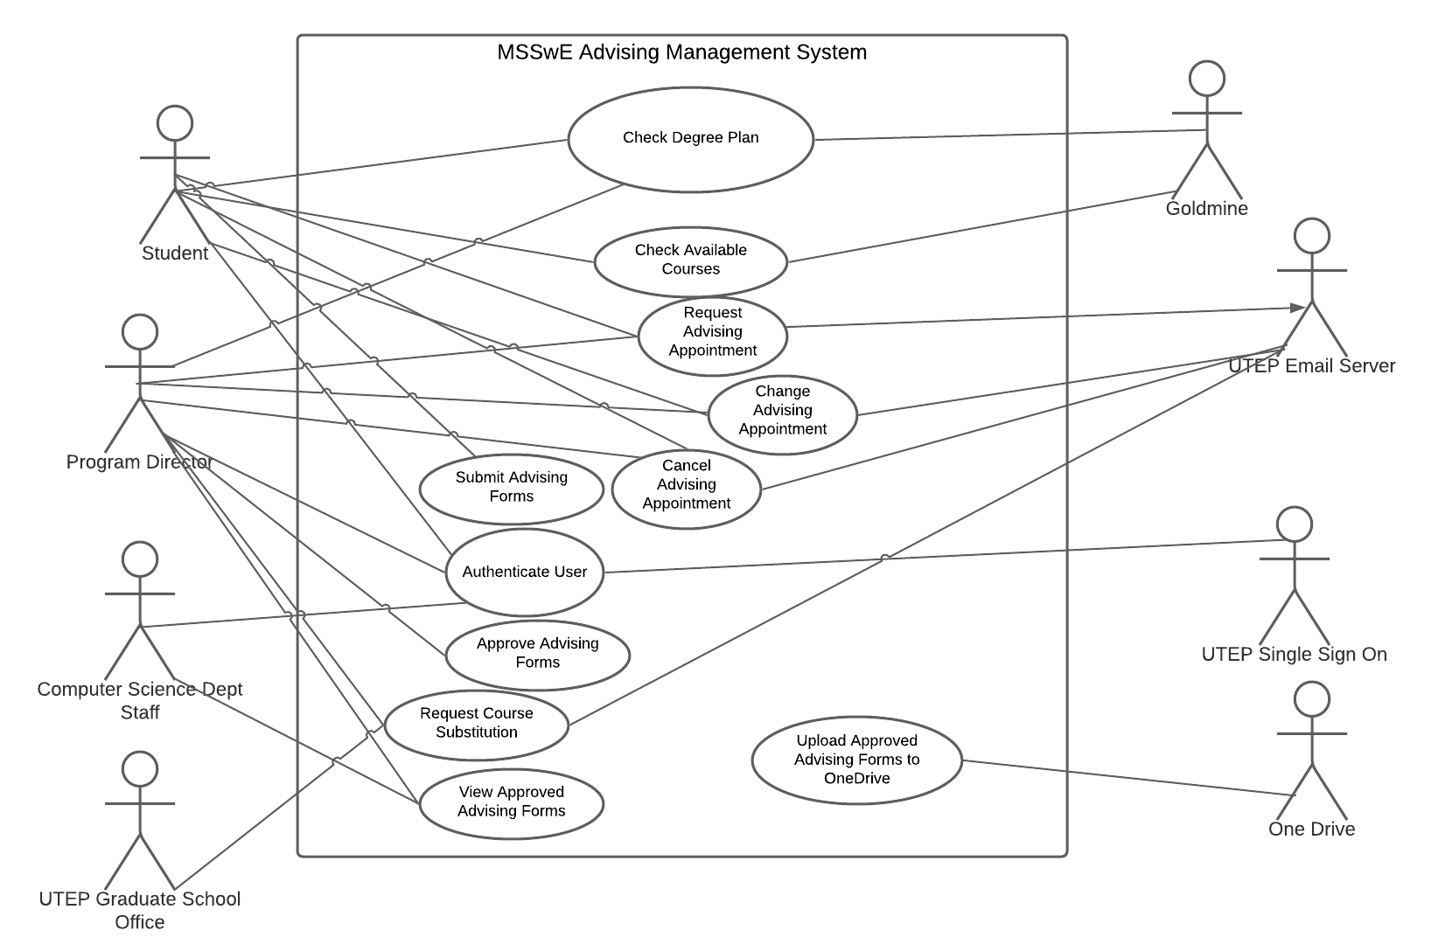

Lucid Chart Link: <https://lucid.app/lucidchart/invitations/accept/87331683-429f-47dc-95c2-ff6f3d605f9e>

## Operational Scenarios

### User Logs In: A_OK

1. User (any user with access) clicks on any link that will take the web browser to the web application.
2. User is redirected to the Single Sign-On login page for UTEP.
3. User Enters his/her valid user credentials.
4. User is redirected to the application landing page where he can access the services associated with his/her role on the system.

### Check Degree Plan: A_OK **(Ask customer)**

1. Students or Program Director log in to the management system via their UTEP/office 365 account.
2. System verifies credentials are valid.
3. System directs users to homepage.
4. User will view different options in the system.
5. User must access Goldmine by selecting and clicking the option.
6. Goldmine will have to create/ populate the degree plan.
7. Goldmine will display a blank screen while the degree plan populates.
8. Goldmine will display the populated degree plan.
9. User will be able to view and analyze the degree plan.

### Check Available Courses: A_OK

1. Students or Program Director log in to the management system via their UTEP/office 365 account.
2. System verifies user credentials.
3. The student then selects the “check available courses” button from the dashboard.
4. The management system will pull data from Goldmine, and display courses that have not been filled, and available during the open student schedule.
5. The system will allow the student to browse through available courses for the designated semester.

### Request Advising Appointment: A_OK**(Ask: What if two users pick the same slot at the same time, how should the system give priority)**

1. Students or Program Director log in to the management system via their UTEP/office 365 account.
2. System verified user credentials.
3. User gains access to system
4. User selects request appointment option.
5. System displays available advising times.
6. User selects an available time.
7. System updates advising schedule for both the student and the program director.
8. System notifies both the student and the program director through email that their appointment have been booked.

### Change Advising Appointment: A_OK

1. Students or Program Director log in to the management system via their UTEP/office 365 account.
2. System verified user credentials.
3. User gains access to system.
4. System shows previously scheduled appointment(s).
5. User selects "Change” appointment option.
6. System displays available advising times.
7. User selects an available time.
8. System updates advising schedule for both the student and the program director.
9. System notifies both the student and the program director through email that their appointment has been updated.

### Cancel Advising Appointment: A_OK**(Ask: Is there a specific time limit a user has in order to cancel an appointment.)**

1. Students or Program Director log in to the management system via their UTEP/office 365 account.
2. System verified user credentials.
3. User gains access to system.
4. System shows previously scheduled appointment(s).
5. User selects "Cancel” appointment option.
6. System displays confirmation dialog.
7. User clicks the “Accept” button.
8. System updates advising schedule for both the student and the program director.
9. System notifies both the student and the program director through email that their appointment has been canceled.

### Submit Advising Forms: A_OK**(Ask: Should the user be able to see the degree plan in this step?)**

1. Students logs in to the management system via their UTEP/office 365 account.
2. System verified user credentials.
3. User gains access to system.
4. User selects the option to “Fill up Advising Form.”
5. System displays advising form pre-filed with the user information obtained from Goldmine.
6. User selects available courses and adds them to the form.
7. User digitally signs and submits the form.
8. User gets confirmation that form has been submitted.
9. Student and Program Director get an email notification stating that the form was submitted.

### Approve Advising Forms: A_OK

1. Program Director logs in to the management system via their UTEP/office 365 account.
2. System verified user credentials.
3. User gains access to system.
4. System display pending advising forms to review.
5. User selects the option to “Review Advising Form.”
6. System displays advising form as well as degree plan for the student with courses taken and grades. All obtained from Goldmine.
7. User reviews and clicks on the button to sign and approve the form.
8. User receives confirmation that the form has been completed.
9. Computer Science Department staff, student advised, and Program Director get an email notification that the form was completed.
10. System uploads completed form to One Drive repository.

### Request Course Substitution Forms: A_OK

1. Program Director logs in to the management system via their UTEP/office 365 account.
2. System verified user credentials.
3. User gains access to system.
4. System display pending advising forms to review.
5. User selects the option to “Review Advising Form.”
6. System displays advising form as well as degree plan for the student with courses taken and grades. All obtained from Goldmine.
7. System notifies the user that a course requested by the student is not part of the degree plan, so a course substitution form is required.
8. User selects the option to complete a course substitution form.
9. Course Substitution form is prepared with the course and student information, so user can review, and add or correct details as needed.
10. User signs the course substitution form which changes the form to a complete status.
11. System will send an email to the UTEP Graduate School office with the course substitution form attached and a carbon copy for the Program Director.
12. Program director is returned to the advising form review page.

### View Completed Advising Forms: A_OK

1. Computer Science Department staff or Program Director logs in to the management system via their UTEP/office 365 account.
2. System verified user credentials.
3. User gains access to system.
4. System display pending advising forms to review.
5. User selects the option to “View Completed Advising Forms.”
6. System displays latest forms by completed date on descending order.
7. Selects a form to view and the system opens the form on a new browser tab.

### Upload Approved Advising Forms: A_OK

1. Program Director approves advising form for a student, which sets the form to an “Completed” status.
2. A scheduled task will run every hour to upload all the advising forms to one drive.
3. The system will send an email to notify the Program Director and the CS Staff users that a new form has been uploaded to One Drive, including the form identifying information, but without identifying personal information that might be sensitive.

# Summary of impacts

## Operational impacts

* System will interface with the UTEP Office 365 One Drive cloud app in order to upload completed advising forms. (Source: Customer Interview I)
* System will interface with the UTEP Email Server to send process notifications and manage advising appointments on the outlook calendar. (Source: Customer Interview I)
* System will interface with the UTEP Single Sign On system in order to authenticate users that need to access the system. (Source: Customer Interview I)
* System will interface with UTEP Goldmine to obtain course catalog, degree plans and student academic history. (Source: Customer Interview II)
* Computer Science Department IT team will need to provide access to the system by adding users to the Active Directory groups that provide access to the different user roles. (Assumption)

## Organizational impacts

* This system would eliminate the need for the program director to be involved in manually sending advising notifications, reminders and course substitutions. ([*Class Project MSSwE Advising Spring 2021.pdf*](https://blackboardlearn.utep.edu/bbcswebdav/pid-3742797-dt-content-rid-118291619_1/xid-118291619_1)*)*
* This system does not require any positions to be created or eliminated, but it aims to increase the efficiency of the advising process. (Assumption)
* Only administrative users will need to be trained to use the functions of the system they have access to. (Assumption)

## Impacts During Development

* Program director will need to review and approve completion of subsystems by performing acceptance testing on every iteration of the system. (Assumption)
* The CS department IT team will need to review and approve the system deployment plan and security configuration before they are implemented, so they verify the system complies with all UTEP policies and regulations. (Source: Customer Interview II)

# Analysis of the proposed system

The new system will automate most of the clerical work that is currently being done by the program director while also streamlining the advising process for the student.

## Benefits

* Enhanced capabilities:
  + check available courses
  + check available courses with seats open
  + add their course grades to the student's records
  + Add student's courses outside prescribed electives
  + Adding course grades
  + Adding courses outside prescribed electives
  + Sending substitutions to graduate school for non-prescribed courses
  + Checking that a program plan meets graduation requirements
  + Uploading program plans and its advising forms

### Disadvantages and limitations

Adding a new user interface can cause discord among the student body. Poor implementation of the system might backfire and turn the situation into a more complex and bothersome experience for the student requesting the advising appointment. The Program Director also needs to learn how to deal with these new types of errors while also trying to learn the user interface.

## Alternatives Considered

Removing the program director completely was considered. By removing the program director, the student does not need to complete an extra task before being able to register to class. The disadvantage with this approach is that many students do not have a plan, thus, they take classes as long as they are in their degree. This can cause problems where the student is stuck because the classes have prerequisites that they have not completed and therefore register to less classes than intended.

Not having an advisor would also make treating special cases harder. Whenever there is a peculiar situation, the advisor can work with the student to resolve it, by removing the program director there is a risk of students getting into problems that spiral out of control and end up affecting their academic standing.

# Notes

# Appendices

**Document Control**

1. **Approval**

Contains a list of the individuals that approves the document or changes to it.

1. **Document Change Control**

|  |  |
| --- | --- |
| Initial Release: | 0.1 |
| Current Release: | 1.0 |
| Indicator of Last Page in Document: | ¨ |
| Date of Last Review: | 3/3/21 |
| Date of Next Review: | 3/5/21 |
| Target Date for Next Update: | 3/10/21 |

1. **Distribution List**
2. This following list of people will receive a copy of this document every time a new version of this document becomes available:

Guidance Team Members: Dr. Mondragon

Customer(s): Adrian Mondragon

Contractor: Team 2

**Revision History**

1. The following table details changes made between versions of this document

| Version | Date | Modifier | Description |
| --- | --- | --- | --- |
| 0.1 | 2/20/21 | Cristian, Diego | First draft of section 3 and 6 |
| 0.2 | 2/23/21 | ALL | First draft of all sections, refinement of 3 and 6 |
| 0/3 | 2/24/21 | ALL | Review of sections. Changes to sections 3 and 6 and completion of all other sections |
| 0.9 | 3/2/21 | Diego, Will | Added and corrected information as a result of learning more about the project on the Customer Interview II |
| 1.0 | 3/3/21 | Diego, Will | Reviewed the document using the Con Ops doc checklist. |

¨